ALP-PGM 1a
WRITE AN ALP TO CONDUCT BINARY SEARCH FOR UNSORTED ARRAY OF N NUMBERS
.MODEL SMALL
.DATA
M1 DB 10,13,"KEY IS FOUND $"
M2 DB 10,13,"KEY IS NOT FOUND $"
A DB 03D,05D,07D,06D,09D
LEN DW $-A
KEY DB 08D
.CODE
MOV AX,@DATA ; DATA SEGMENT INITILALIZE
MOV DS,AX
MOV AX,@DATA
MOV DS,AX
LEA SI,A
MOV BX,LEN
DEC BX
N2:MOV CX,BX
LEA SI,A
N1:MOV AL,[SI]
INC SI
CMP AL,[SI]
JBE NOSWAP
XCHG AL,[SI]
MOV [SI-1],AL
NOSWAP: LOOP N1
DEC BX
JNZ N2
LEA SI,A ; SI POINTING TO ARRAY A
MOV DI,SI
ADD DI,LEN ; DI POINTING TO THE LAST ELEMENT IN ARRAY A
DEC SI
L1: CMP SI,DI
JA NF
MOV BX,SI
ADD BX,DI
SHR BX,01H; SHIFT RIGHT TO DIVIDE IT TWO TIMES
MOV AL,KEY
CMP AL,[BX]; COMAPRE AL WITH BX CONTENT
JZ FOUND
JA NLOW
MOV DI,BX
DEC DI
JMP L1; JUMPING TO LOOP L1
NLOW: MOV SI,BX
INC SI
JMP L1
NF: LEA DX,M2
JMP EXIT
FOUND: LEA DX,M1
EXIT: MOV AH,09H; TO PRINT IT ON SCREEN
INT 21H
MOV AH,4CH
INT 21H
END
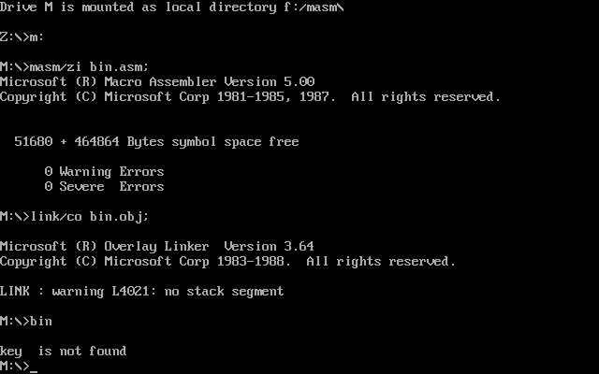

ALP-PGM 2a
READ AN ALPHANUMERIC CHARACTER AND DISPLAY ITS EQUIVALENT ASCII CODE AT THE CENTER OF THE SCREEN.

ALP-PGM 3a
WRITE AN ALP TO AN 8BIT NUMBER FROM THE KEYBOARD AND CHECK WHETHER IT IS A PRIME NUMBER OR NOT
.MODEL SMALL
.DATA
M1 DB 10,13,'ENTER THE NUMBER $'
M2 DB 10,13,'IT IS PRIME $'
M3 DB 10,13,'IT IS NOT PRIME $'
NUM DW ?
F DB 00H
.CODE
MOV AX,@DATA
MOV DS,AX
LEA DX,M1
MOV AH,09H
INT 21H
MOV AH,01H; READING FROM KEYBOARD

INT 21H
SUB AL,30H; SUBTRACTING AND DISPLAYING ON SCREEN
MOV BL,AL
MOV AH,00H
AAD; ADJUSTING ASCII AFTER DIVISION TO UNPACK BCD
MOV NUM,AX
MOV CX,NUM
T1: MOV DX,00H
MOV AX,NUM
DIV CX; DIVIDE WITH AX/CX
CMP DX,00H
JZ P1
JMP J1
P1: INC F
J1: LOOP T1
CMP F,02H
JNZ J2
LEA DX,M2
MOV AH,09H
INT 21H
JMP EXIT
J2: LEA DX,M3
MOV AH,09H
INT 21H
EXIT: MOV AH,4CH
INT 21H
END
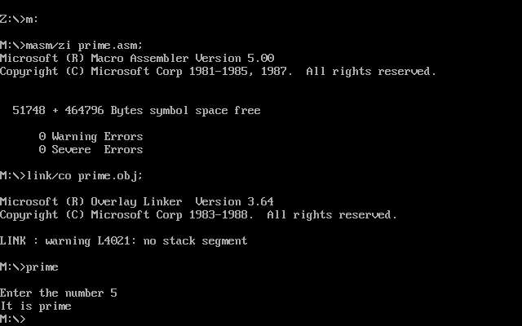

ALP-PGM 4a
WRITE AN ALP TO READ A STRING FROM THE KEYBOARD AND CHECK WHETEHER IT IS A PALINDROME OR NOT
.MODEL SMALL
.DATA
BUF1 DB 100
L DB ?
STR DB 100(?)
RSTR DB 100(?)
M1 DB 10,13,"ENTER THE STRING $"
M2 DB 10,13,"IT IS PALINDROME $"
M3 DB 10,13,"IT IS NOT PALINDROME $"
.CODE
MOV AX,@DATA
MOV DS,AX
MOV ES,AX; USE OF EXTRA SEGMENT
LEA DX,M1
MOV AH,09H
INT 21H
LEA DX,BUF1; BUF1 POINTING TO DX
MOV AH,0AH; READING STRING FROM KEYBOARD
INT 21H
MOV CL,L
MOV CH,00H
LEA SI,STR
ADD SI,CX
DEC SI
LEA DI,RSTR
L1: MOV AL,[SI]
MOV [DI],AL
DEC SI
INC DI
LOOP L1
LEA SI,STR
LEA DI,RSTR
CLD; CLEAR DIRECTION FLAG
MOV CL,L
MOV CH,00H
REPE CMPSB; STRING COMPARE INSTRUCTION
JZ PALI
LEA DX,M3
JMP EXIT
PALI: LEA DX,M2
EXIT: MOV AH,09H; DISPLAY MEASSAGE
INT 21H
MOV AH,4CH
INT 21H
END
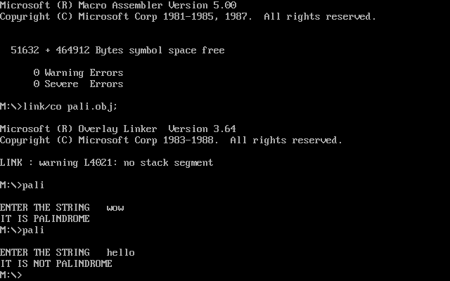

ALP-PGM 5a
WRITE AN ALP TO READ TWO STRINGS, STORE THEM IN LOCATIONS STR1 AND STR2. CHECK WHETEHER THEY ARE EQUAL OR NOT AND DISPLAY APPROPRIATE MESSAGES. ALSO DISPLAY THE LENGHT OF THE STORED STRINGS.\

.MODEL SMALL
.DATA
M1 DB 10,13,"ENTER 1ST STRING: $"
BUFF1 DB 100
LEN1 DB ?
STR1 DB 100 DUP(?)
M2 DB 10,13,"ENTER 2ND STRING: $"
BUFF2 DB 100
LEN2 DB ?
STR2 DB 100 DUP(?)
M1LEN DB 10,13,"LEN OF STR1 IS : $"
M2LEN DB 10,13,"LEN OF STR2 IS : $"
M3 DB 10,13,'STRINGS ARE EQUAL!$'
M4 DB 10,13,'STRINGS ARE NOT EQUAL.$'

.CODE
MOV AX,@DATA
MOV DS,AX
MOV ES,AX

LEA DX,M1 ;ENTER STRING MESSAGE
CALL PRINTF
LEA DX,BUFF1 ;ENTER STRING 1
CALL PUTS
LEA DX,M2
CALL PRINTF
LEA DX,BUFF2 ;ENTER STRING 2
CALL PUTS
MOV AL,LEN1
CMP AL,LEN2
JNZ NOTEQUAL

;COMPARE STRINGS
MOV CX,00H
MOV CL,LEN1
LEA SI,STR1
LEA DI,STR2
CLD
REPE CMPSB
JZ STREQUAL

NOTEQUAL: LEA DX,M4
CALL PRINTF
JMP EXIT

STREQUAL: LEA DX,M3
CALL PRINTF

EXIT: LEA DX,M1LEN ;PRINT STR1 LEN
CALL PRINTF
MOV DL,LEN1
CALL PRINTL
LEA DX,M2LEN ;PRINT STR1 LEN
CALL PRINTF
MOV DL,LEN2
CALL PRINTL
MOV AH,4CH
INT 21H

PRINTF PROC NEAR
MOV AH,09H
INT 21H
RET
PRINTF ENDP

PUTS PROC NEAR
MOV AH,0AH
INT 21H
RET
PUTS ENDP

PRINTL PROC NEAR
MOV AX,00H
MOV AL,DL
MOV BX,10D
MOV CX,00H
L1: MOV DX,00H
DIV BX
PUSH DX
INC CX
CMP AX,00H
JNZ L1
L2: POP DX
ADD DX,30H ;CONVERT TO ASCII
MOV AH,02H ;CHAR DISPLAY
INT 21H
DEC CX
JNZ L2
RET
PRINTL ENDP
END

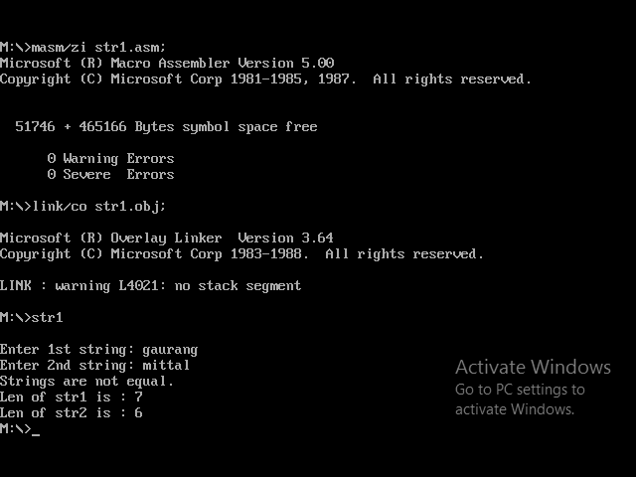

ALP-PGM 6a
WRITE AN ALP TO GENERATE AND PRINT FIRST N FIBONACCI NUMBERS.

.MODEL SMALL
.DATA
VAL1 DB 00H
VAL2 DB 01H
LP DB 0H
V1 DB 0H
V2 DB 0H
NL DB 10,13,'$'
M1 DB 10,13,'ENTER A NUMBER $'
M2 DB 10,13,'FIBONACCI$'
.CODE
MOV AX,@DATA
MOV DS,AX
LEA DX,M1
MOV AH,09H; DISPLAY STRING MEASSAGE
INT 21H
MOV AH,01H; READING FROM KEYBOARD
INT 21H
MOV CL,AL
SUB CL,30H; SUBTRACTING 30 TO GET ORIGINAL NUMBER
SUB CL,2D
LEA DX,NL
MOV AH,09H
INT 21H
MOV AH,02H
MOV DL,VAL1
ADD DL,30H
INT 21H
MOV AH,09H
LEA DX,NL
INT 21H
MOV AH,02H
MOV DL,VAL2
ADD DL,30H
INT 21H
LEA DX,NL; DX POINTIING TO NL REGISTER
MOV AH,09H
INT 21H
DISP: MOV BL,VAL1
ADD BL,VAL2
MOV AH,00H
MOV AL,BL
MOV LP,CL
MOV CL,10
DIV CL
MOV CL,LP
MOV V1,AL
MOV V2,AH
MOV DL,V1
ADD DL,30H
MOV AH,02H
INT 21H
MOV DL,V2
ADD DL,30H
MOV AH,02H
INT 21H
MOV DL,VAL2; INTERCHANGING THE VALUES
MOV VAL1,DL
MOV VAL2,BL
LEA DX,NL
MOV AH,09H
INT 21H
LOOP DISP
MOV AH,4CH
INT 21H
END

